Where the Smart Money is


Investing in Pittsburgh Real Estate


Helping the World Build Wealth and Income through Real Estate
www.RealEstateandPittsburgh.com
Gary Wilson, Broker/Owner
Gary@WinRealtyAdvisors.com
412-415-3328
Dear Dr…….. ,

The purpose of this letter is to introduce you to Win Realty Advisors, LLC and reality that you can successfully invest in Pittsburgh Real Estate even though you are already extremely busy. Win Realty Advisors, LLC was created to offer owners of investment real estate creative solutions that will help you earn more money with less problems. As a result developing relationships with several doctors I decided to reach out to you. A recurring theme from your colleagues is that you are short on time, are tired of feeling like a target for stock brokers and other financial planners who keep telling you to “hang in there”, and quite frankly want to see others who have succesfully invested in Real Estate before you dive in. I have helped pilots, US Service men and women, and many others get great results from investing in Pittsburgh Real Estate while keeping risks in check.

The principals of Win Realty Advisors, LLC are first and foremost real estate investors. We buy investment properties, apartment buildings and commercial real estate investments throughout Western Pennsylvania and have been investing in real estate for more than 25 years. We are also advisors that assist property owners with all aspects of their investments including new acquisitions, dispositions of existing properties, as well as property management and leasing services. We have an extensive network of national and international investors that are actively seeking investment properties. Some owners choose to access our buyer network to obtain a more aggressive price for their property. Other owners find it easier to deal directly with us as the buyer. Our goal is to provide you with several exit strategies for your property which will allow you to choose the option that is best for you.

If you have ever considered investing in Real Estate and have not been able to make the time to do so or if you have considerd selling an investment property and profit from it then please call Gary WIlson at (412) 415-3328 for an initial conversation. We will discuss your needs and goals with you and help to determine if there is a mutually beneficial arrangement that helps you achieve your goals. I hope you enjoy the enclosed catalog I look forward to hearing from you.

Sincerely,

Gary Wilson
Broker/Owner
Win Realty Advisors, LLC
100 Center Avenue
Pittsburgh, PA 15229
(412) 415-3328
Gary@WinRealtyAdvisors.com
Table of Contents:
- Recent article from Gary Wilson
- Available Real Estate Investment Properties sorted by price from low to high
- Alternative to investing in Real Estate through Bradley Capital
- Related Services
If you are like most other doctors, and some of our other clients, and are fed up with the stock market and financial advisors telling you to just be patient and you previously considered investing in Real Estate too time consuming then please call or email me and the Win Realty Advisors Team to find out how you can finally begin putting your hard earned money to good use. We not only invest in Real Estate, we invest in people just like you. It’s easier than you may have thought. We look forward to helping you. Please take the 1st step and call today. There are no obligations Sincerely, Gary Wilson.

www.RealEstateandPittsburgh.com
412-415-3328
Gary Wilson, Broker/Owner
Gary@WinRealtyAdvsirors.com
Helping the World Build Wealth and Income through Real Estate



I’m done with the stock market. Should I buy a duplex instead?

By Gary Wilson Broker and Founder of Win Realty Advisors, LLC

Excellent question. May I answer you by giving you a real world example? This is a property I bought and held for 11 years. Following are two Pro-Formas – one describing the financial picture when I bought the building and one describing the financial picture when I sold it. Here is a brief description of some of the terminology used below:

Net Operating income ( NOI ) = income less expenses ( does not include mortgage payments )
Debt Service = principle plus interest on loan
Cash on Cash Return = NOI – less debt service / down payment + capital improvements
Cap Rate = NOI / sales price ( cost basis )

741 Florence: Up and down duplex, new siding and roof, separate G + E and water , 2 new furnaces. Tenants pay G + E. Residential neighborhood.
WHEN I BOUGHT IT
income: 900/mo ( 1st fl 1 bedr = 375, 2nf + 3rd fl 2 bedr = 525) = 10,800
taxes: 2051/yr
insurance: 351yr
maint/repair: 600/yr
water: 1,061
Net Operating Income: 561/mo = 6737 yr
Purchase price: 42,000
Down payment: 5,000
Loan: 37,000 30 yrs, 8 %
Debt Service: 271/mo ( principle plus interest )
Cash return: 290/mo = 3485/yr
Cash on Cash return rate = 70%
Cap Rate = 16%

741 Florence: Up and down duplex, new siding and roof, separate G + E and water , 2 new furnaces. Tenants pay G + E. Residential neighborhood.
WHEN I SOLD IT
income: 1,000/mo ( 1st fl 1 bedr = 450, 2nf + 3rd fl 2 bedr = 550) = 12,000
taxes: 2246/yr
insurance: 351yr
maint/repair: 600/yr
water: 1,061
management: 840
Net Operating Income: 575/mo = 6902 yr
Purchase price: 72,000
Down payment: 15,000
Loan: 57,000, 20 yrs, 5 %
Debt Service: 376.17/mo
Cash return: 200/mo = 2400/yr
Cash on Cash return rate = 16%
Cap Rate = 9.5%

Let’s discuss this for a moment. First of all, when I bought the building the market was different than it is today. Notice I only put down 5%. Today you would be required to put down 20%. The only thing that would change materially is the cash on cash return. Also, interest rates back then were much higher than they are today. Also, please notice that when I bought the property I didn’t have property management. Big mistake. I later, wisely decided to use Property Management. I actually make more money using property management. They’re better at dealing with tenants and repairmen than I am. I’m better at finding more properties to invest in. The women who bought this got a good deal. I got a great deal. Everybody wins !

The bottom line is this :
- I put up $5,000 of my own money
- I made about $3,000 per year positive cashflow ( actually it improved over the ten years I owned the building but I’m being conservative here)
- I got to take the IRS depreciation write off of 3.5% every year of ownership
( assuming a 15% tax bracket this roughly equal to an additional $15,400 )
- The mortgage was paid down by $5,000 over the eleven year period and this was of course covered by my rental income
- The building went up in value
- I sold the building for $72,000 after 11 years ( difference of $30,000 )
- When you add it all up I turned $5,000 into more than $70,000 in 11 years and that doesn’t include the tax savings from depreciation !

Should you buy a duplex? I did. In fact I bought a lot of them. Do I have money in the stock market ? Not anymore. For me the difference comes down to control. There are basically only two moves you and I can make in the stock market – buy and sell – and we have no control whatsoever over that underlying asset in between the buy and the sell. With Real Estate, I can not only buy it and sell it, but I can modify it and improve it. I can raise the rents. I can refinance it and use that leverage to buy more property. You see with Real Estate I am in control. I’m 48 years old now and I have learned the hard way that whenever I give up too much control it cost me money. The more control I retain the more money I make.

Investing in Real Estate is not very glamorous. It takes time and energy and in today’s market it takes money. Yes, you can buy real estate without any of your own money, but today it’s easier if you use your own money. The banks will give you the best rates and terms when you use your own money. I know this runs contrary to a lot of what you read and watch on late night television but it is the simple truth. Take the path of least resistance. There are several ways to buy Real Estate and only 2 basic ones – the way implied above and the other way which is buy wholesale, remodel, refinance. The banks are not looking favorably on the latter approach these days. Actually, some lenders will finance your purchase and remodeling at the same time but you still need 20% down !

I hope this example sheds some light on what many perceive to be a little mysterious. It really isn’t magic. There are no secrets. It is actually quite simple. I have one friend who didn’t finish high school and she owns over 100 units free and clear and she did it in 15 years ! In a little over 10 years I managed to get my name on 250 units and I am regular guy. I drive a pickup truck with over 130,000 miles on it. I pack my own lunch. I did the corporate America gig for 18 years and I hated it. I had no freedom. My spirit was dying. Now I love my freedom and independence and I thank God every day for Real Estate because every time I bought a little piece of Real Estate I also I bought a little piece of freedom. God Bless America and God bless you for reading this article. I sincerely hope and pray it will help you see a real world alternative for investing your hard earned dollars.

Yours Truly,
Gary Wilson

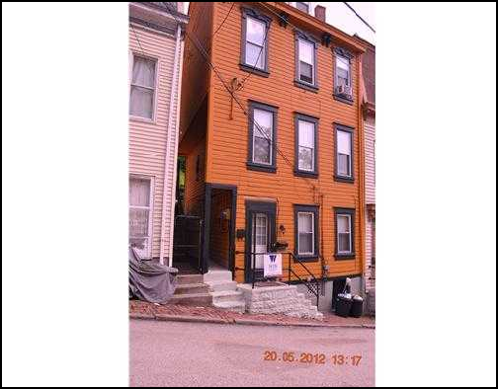
MLS#: 915434 Status: Active
Multi-Unit 38 Rostock

Area: Spring Hill List Price: $59,900
County: North Allegheny
Address: 38 Rostock Zip Code : 15212
Dir: 279N to East St, R on Rostock

Lot: 30x60 Acres: 0.04 Map#/Block#/Lot#/Info: 0024-A-00142-0000-00 Zoning: R2
School Dist: Pittsburgh

School Trans: Public Trans: Y
General Information

GAI:
$12,840 Maintenance: $500

Total Units:
2 Baths

Vacancy: | 3 % $385 | Other Exp: |  |  |  | Beds | Full | Partial | Rent
GOI: | $12,455 | NOI: | $9,436 | 1 | 1 | 2 | 1 | 1 | 525

Insurance: $391 Cash Required: Utility Exp: $1,148
2 1 2 1 545

3
4

Remarks
NOTE: ! Price drop ! Turnkey duplex with new paint, HW heaters, kitchens, baths, and heat. Tenants pay utilities except water. 12CAP at purchase. HUGE CASH FLOW. Detailed financials attached.

Agent Remarks
MANDATORY - 48 Hour Notice to Show - Must call Dawn at Win Rental Management 412-758-2439 to arrange showing with tenant.

Features
Type Property: Duplex Years Old:
Basement: Y, U Construction: Frame
Parking: , On-Street Parking Insulation: Yes
Show: Appointment With Listor Roof: Utilities Avail: Gas, Electricity, Water, Sewer

Office Information

Value: Market Value - $35,900

Tenant Occ: Y
Taxes: $980

ICD: N Entered: GW:OFC Foreclosure:

BAC: 3
SAC: 0

TLC: 0 Short Sale:

Owner: MZE2008 LLC Tour Date:
Contact: Dawn Phone: 412-758-2439
Agent: Gary Wilson Phone: 412-415-3850 Cell Phone: 412-680-3618
List Office: WIN REALTY ADVISORS, LLC Phone: 412-415-3328 Office ID: 84001

Tour URL:

List Date: | 05/08/12 | Expire Date: | 05/08/13 | Pending Date:
Sold Date: |  | Sold Price: |  | Sold Terms:
Selling Office ID: |  | Office Name: |  | Phone:
Selling Agent ID: |  | Agent Name: |  | Phone:
DOM: |  | Buyer Name: |  | Seller Concessions:

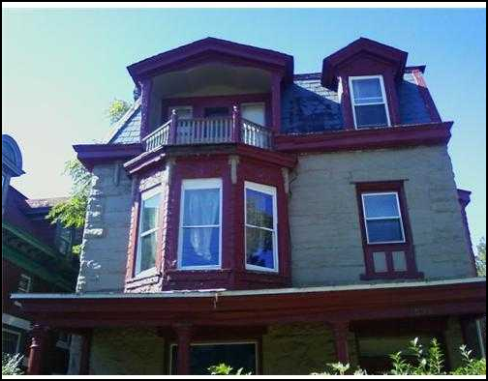
MLS#: 910833 Status: Active
Multi-Unit 2835 Perrysville Road

Area: Perry Hilltop List Price: $64,900
County: North Allegheny
Address: 2835 Perrysville Road Zip Code : 15214
Dir: Perrysville just south of Marshall. House on right.

Lot: 45x130 Acres:
Map#/Block#/Lot#/Info: 77-P-00020

Zoning:
School Dist: Pittsburgh

School Trans: y Public Trans: y
General Information

GAI: $12,900  Vacancy: | Maintenance: Other Exp: | $600 | Total Units: | 2 | Beds | Baths Full | Partial | Rent
GOI: | NOI: | $7,964 | 1 | 1 | 1 | 1 |  | 450
Insurance: $322 | Cash Required: |  | 2 | 1 | 3 | 1 |  | 675
Utility Exp: $1,136 |  |  | 3
 |  |  | 4
Remarks
Turnkey duplex in highly desirable Pittsburgh area. New and separate gas, electric and new furnaces. Strong double digit cash on cash returns from day one. This property is fully rented but always easy to rent.

Agent Remarks
Need to allow 48 hours showing notice for tenants.

Features
Type Property: Duplex Years Old:
Basement: y, full Construction:
Parking: 2, Off-Street Parking Insulation:
Show: Appointment With Listor Roof: Utilities Avail:

Office Information

Value: Market Value - $40,000

Tenant Occ: Y
Taxes: $1,201

ICD:
N Entered: GW:OFC Foreclosure: N

BAC: 3
SAC: 3
TLC: 0

Short Sale: N

Owner: AA Holdings Tour Date:
Contact: Dawn Phone: 412-758-2439
Agent: Gary Wilson Phone: 412-415-3850 Cell Phone: 412-680-3618
List Office: WIN REALTY ADVISORS, LLC Phone: 412-415-3328 Office ID: 84001

Tour URL:

List Date: | 04/09/12 | Expire Date: | 04/09/13 | Pending Date:
Sold Date: |  | Sold Price: |  | Sold Terms:
Selling Office ID: |  | Office Name: |  | Phone:
Selling Agent ID: |  | Agent Name: |  | Phone:
DOM: |  | Buyer Name: |  | Seller Concessions:

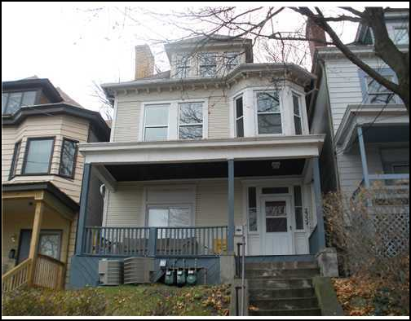
MLS#: 913931 Status: Active
Multi-Unit 2334 Maple

Area: Perry Hilltop List Price: $64,500
County: North Allegheny
Address: 2334 Maple Zip Code : 15214
Dir: Federal St. to E. Burgess - Right on Maple

Lot: 40x70 ml Acres: Map#/Block#/Lot#/Info: 0048-F-00274-0000-00 Zoning:
School Dist: Pittsburgh

School Trans: Public Trans: Y
General Information

GAI: | $15,060 | Maintenance: | $675 | Total Units: | 2 |  | Baths
Vacancy: | 5 % $675 | Other Exp: | $1,296 |  |  | Beds | Full | Partial | Rent
GOI: | $14,385 | NOI: | $9,512 | 1 |  | 1 | 1 |  | 460

Insurance: $667 Cash Required: Utility Exp: $1,320
2 2 1 620

3
4

Remarks
GREAT TURNKEY Opportunity. Completely renovated in 2010. New electrical, plumbing, furnace and hot water tank. Both units have central air. Appliances included. Washer/Dryer hookups. New deck. Great Cash Flow!!!

Agent Remarks
Please allow 48 hr notice. Tenant Occuppied. Call listing agent for access. Taxes are estimated.

Features
Type Property: Duplex Years Old: 999
Basement: Y, Unfin Construction: Frame
Parking: , On-Street Parking Insulation: Unknown
Show: Other Roof: Asphalt
Utilities Avail: Gas, Electricity, Water, Sewer

Office Information

Value: ICD: | Market Value - $30,400 N | Tenant Occ: Entered: |  | Y HS:OFC | Taxes: $915  Foreclosure: | N
BAC:  SAC: | 3.5/2000  3.5/2000 | TLC: |  | 0 | Short Sale: | N
Owner: | Elbow River, LLC | Tour Date:
Contact: Heather |  | Phone: | 412-302-6723
Agent: Heather Simonetti |  | Phone: | 412-302-6723 |  | Cell Phone: 412-302-6723
List Office: WIN REALTY ADVISORS, LLC |  | Phone: | 412-415-3328 |  | Office ID: 84001
Tour URL:

List Date: | 04/29/12 | Expire Date: | 04/29/13 | Pending Date:
Sold Date: |  | Sold Price: |  | Sold Terms:
Selling Office ID: |  | Office Name: |  | Phone:
Selling Agent ID: |  | Agent Name: |  | Phone:
DOM: |  | Buyer Name: |  | Seller Concessions:

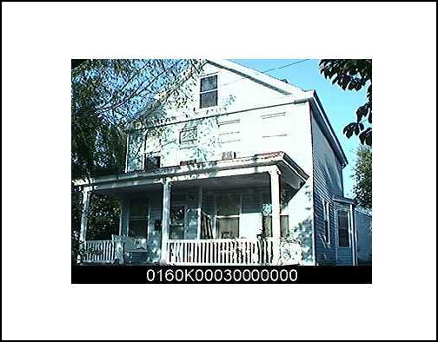
MLS#: 896143 Status: Active
Multi-Unit 25S Sprague St

Area: Bellevue List Price: $84,900
County: North Allegheny
Address: 25S Sprague St Zip Code : 15202
Dir: N on Lincoln from Balph Ave, L on SSprague Home on right.

Lot: 50x150 Acres:
Map#/Block#/Lot#/Info: 160-k-00030

Zoning:
School Dist: Northgate

School Trans: Public Trans: y
General Information

GAI:  Vacancy: | Maintenance: Other Exp: | $900 | Total Units: | 3 | Beds | Baths Full | Partial | Rent
GOI: | NOI: |  | 1 | 1 | 1 | 1 |  | 400
Insurance: $565 | Cash Required: |  | 2 | 1 | 3 | 1 |  | 460
Utility Exp: |  |  | 3 | 1 | 1 | 1 |  | 475
 |  |  | 4
Remarks
Large up and down duplex with plus carriage house, All utilities are separate. Residential neighborhood. 1st floor 1 bedroom = 400/mo, 2nd + 3rd floor 3 bedroom = 460/mo, rear = 475/mo

Agent Remarks
48 hours required to give tenants notice for showing. Example of financing: Loan: 72,000, 20 yrs, 5 % Debt Service: 475.17/mo Cash return: 564.48/mo Cash on Cash return rate = 37%, Cap Rate = 13.86%

Features
Type Property: Triplex Years Old: 103
Basement: y, unfin Construction: Frame
Parking: , On-Street Parking Insulation:
Show: Appointment With Listor Roof: Utilities Avail:

Office Information

Value: Market Value - $54,000

Tenant Occ: Y
Taxes: $2,079

ICD:
N Entered: GW:OFC Foreclosure: N

BAC: 3
SAC: 3
TLC: 0

Short Sale: N

Owner: Wilson Tour Date:
Contact: Dawn Phone: 412-301-0586
Agent: Gary Wilson Phone: 412-415-3850 Cell Phone: 412-680-3618
List Office: WIN REALTY ADVISORS, LLC Phone: 412-415-3328 Office ID: 84001

Tour URL:

List Date: | 11/28/11 | Expire Date: | 11/27/12 | Pending Date:
Sold Date: |  | Sold Price: |  | Sold Terms:
Selling Office ID: |  | Office Name: |  | Phone:
Selling Agent ID: |  | Agent Name: |  | Phone:
DOM: |  | Buyer Name: |  | Seller Concessions:

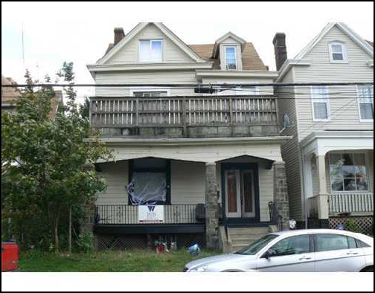
MLS#: 891570 Status: Active
Multi-Unit 233 Marshall Avenue

Area: Perry Hilltop List Price: $84,900
County: North Allegheny
Address: 233 Marshall Avenue Zip Code : 15214
Dir: Down Perrysville, R on Marshall

Lot: 27x179 Acres:
Map#/Block#/Lot#/Info: 77-N-00070

Zoning:
School Dist: Pittsburgh

School Trans: y Public Trans: y
General Information

GAI: $18,300  Vacancy: | Maintenance: Other Exp: | $600 | Total Units: | 2 | Beds | Baths Full | Partial | Rent
GOI: | NOI: | $13,886 | 1 | 1 | 2 | 1 |  | 550
Insurance: $372 | Cash Required: |  | 2 | 1 | 5 | 1 | 0 | 750
Utility Exp: $2,400 |  |  | 3 | 1 | 0 | 0 | 0 | 225 gar
 |  |  | 4
Remarks
Large up and down duplex with 4 bay garage, new and separate gas and electric and new furnaces. Tenants pay gas & electric. Owner pays water/sewage/garbage. Residential neighborhood.

Agent Remarks
Example Financing Terms: Loan: 76,000, 20 yrs, 5 %. Debt Service: 501.57/mo Cash return: 641.56/mo = 7698.72/yr Cash on Cash return rate
= 40.5%, Cap Rate = 14%. 48 HRS NOTICE TO SHOW - MINIMUM. NO EXCEPTIONS.

Features
Type Property: Duplex Years Old: 111
Basement: y, Construction: Aluminum
Parking: 4, Detached Garage Insulation:
Show: Appointment With Listor Roof: Asphalt

Utilities Avail:
Office Information

Value: Market Value - $35,000

Tenant Occ: Y
Taxes: $1,042

ICD:
N Entered: GW:OFC Foreclosure: N

BAC: 3
SAC: 3
TLC: 0

Short Sale: N

Owner: G&S Holdings Tour Date:
Contact: Dawn Phone: 412-758-2439
Agent: Gary Wilson Phone: 412-415-3850 Cell Phone: 412-680-3618
List Office: WIN REALTY ADVISORS, LLC Phone: 412-415-3328 Office ID: 84001

Tour URL:

List Date: | 10/13/11 | Expire Date: | 10/12/12 | Pending Date:
Sold Date: |  | Sold Price: |  | Sold Terms:
Selling Office ID: |  | Office Name: |  | Phone:
Selling Agent ID: |  | Agent Name: |  | Phone:
DOM: |  | Buyer Name: |  | Seller Concessions:

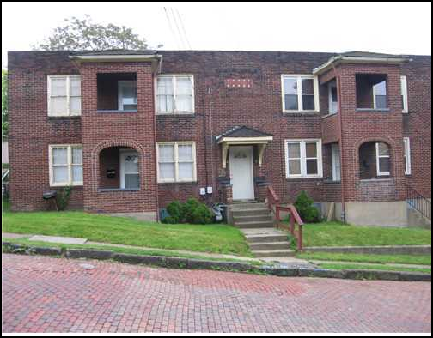
MLS#: 916675 Status: Active
Multi-Unit 3410 Garbett

Area: McKeesport List Price: $88,500
County: East Allegheny
Address: 3410 Garbett Zip Code : 15132
Dir: Versailles Ave, Grandview right on Garbett Walnut to Patterson (30th) right on Garbett

Lot: 100x75 Acres:
Map#/Block#/Lot#/Info: 0381-G-00112

Zoning:
School Dist: McKeesport Area

School Trans: y Public Trans: y
General Information

GAI:
$22,320 Maintenance: $1,200

Total Units:
4 Baths

Vacancy: | 5 % $1,116 | Other Exp: | $500 |  |  | Beds | Full | Partial | Rent
GOI: | $21,204 | NOI: | $13,462 | 1 | 3 | 2 | 1 |  | 475

Insurance: $800 Cash Required: Utility Exp: $2,000
2 1 2 1 435

3
4

Remarks
Cash flow and professional property manangement make this a true turnkey investment. Many updated windows and updates in most units. Seperate entries and utilities make this a great property for the tenants and owner. Five garages in the back for additional income. Two are currently rented for $35/month each.

Agent Remarks
See attachments for detailed income and expenses projections. Need 24 hours notice to show.

Features
Type Property: Fourplex Years Old:
Basement: y, full Construction: Brick
Parking: 5, Detached Garage Insulation:
Show: Appointment With Listor Roof: Utilities Avail: Gas, Electricity, Water, Sewer

Office Information

Value: Market Value - $58,100

Tenant Occ: Y
Taxes: $1,676

ICD: N Entered: cf:OFC Foreclosure:

BAC: 3
SAC: 0

TLC: 0 Short Sale:

Owner: TDL 1 Development LLC Tour Date:
Contact: Cory Fast Phone: 412-965-6060
Agent: Cory Fast Phone: 412-965-6060 Cell Phone:
List Office: WIN REALTY ADVISORS, LLC Phone: 412-415-3328 Office ID: 84001

Tour URL:

List Date: | 05/17/12 | Expire Date: | 05/17/13 | Pending Date:
Sold Date: |  | Sold Price: |  | Sold Terms:
Selling Office ID: |  | Office Name: |  | Phone:
Selling Agent ID: |  | Agent Name: |  | Phone:
DOM: |  | Buyer Name: |  | Seller Concessions:

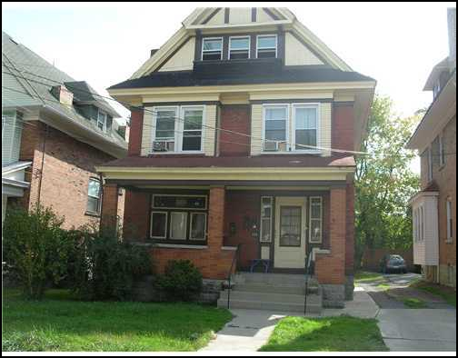
MLS#: 921089 Status: Active
Multi-Unit 159 Kendall

Area: Bellevue List Price: $99,900
County: North Allegheny
Address: 159 Kendall Zip Code : 15202
Dir: Lincoln towards Pgh, right on Kendall, House on left, do NOT park in driveway

Lot: 40.625X120 approx Acres: Map#/Block#/Lot#/Info: 0113-H-00133-0000-00 Zoning:
School Dist: Northgate

School Trans: y Public Trans: y
General Information

GAI: | $16,500 | Maintenance: | $840 | Total Units: | 3 |  | Baths
Vacancy: | 2% % $330 | Other Exp: |  |  |  | Beds | Full | Partial | Rent
GOI: | $16,170 | NOI: | $11,912 | 1 |  | 2 | 1 |  | 500
Insurance: $720 |  | Cash Required: |  | 2 |  | 2 | 1 |  | 500
Utility Exp: $400 |  |  |  | 3 |  | 1 | 1 |  | 375
 |  |  |  | 4
Remarks
Solid brick building in the heart of Bellevue. All new windows throughout the entire property were recently replaced. All kitchens and bathrooms have been updated. Sidewalks are new. Tenants pay gas and electric. Landlord only pays for water and sewage for apts 1 & 3. Brand new 11K fire escape recently installed. Property is priced below market to sell.

Agent Remarks
Owner is licensed real estate agent, 2013 property assessment is 146,900 which has been appealed. Required 24 hour notice to show.

Features
Type Property: Triplex Years Old: 90
Basement: y, full Construction: Brick
Parking: 2, Off-Street Parking Insulation: Unknown
Show: Appointment With Listor Roof: Asphalt
Utilities Avail: Gas, Electricity, Water, Sewer

Office Information

Value: Market Value - $58,500

Tenant Occ: Y
Taxes: $2,298

ICD:
Y Entered: vp:OFC Foreclosure: N

BAC: 3
SAC: 0
TLC: 0

Short Sale: N

Owner: D and V Properties, LP Tour Date:
Contact: Vince Parrucci Phone: 724-612-3770
Agent: Vince Parrucci Phone: 724-612-3770 Cell Phone: 724-612-3770
List Office: WIN REALTY ADVISORS, LLC Phone: 412-415-3328 Office ID: 84001

Tour URL:

List Date: | 06/12/12 | Expire Date: | 06/12/13 | Pending Date:
Sold Date: |  | Sold Price: |  | Sold Terms:
Selling Office ID: |  | Office Name: |  | Phone:
Selling Agent ID: |  | Agent Name: |  | Phone:
DOM: |  | Buyer Name: |  | Seller Concessions:

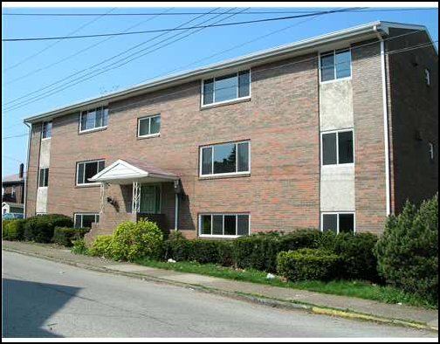
MLS#: 901557 Status: Active
Multi-Unit 1600 Sumac Street

Area: McKeesport List Price: $144,900
County: East Allegheny
Address: 1600 Sumac Street Zip Code : 15132
Dir: Walnut St to L on 30th, 30th turns into Patterson, L on Garbert st, L on Sumac

Lot: 38 x 90 m/l Acres:
Map#/Block#/Lot#/Info: 381- G - 155

Zoning:
School Dist: McKeesport Area

School Trans: Y Public Trans: Y
General Information

GAI:  Vacancy: | Maintenance: Other Exp: | $500 | Total Units: | 6 | Beds | Baths Full | Partial | Rent
GOI: | NOI: |  | 1 | 2 | 2 | 1 |  | 525
Insurance: $2,271 | Cash Required: |  | 2 | 1 | 1 | 1 |  | 475
Utility Exp: $5,480 |  |  | 3 | 1 | 2 | 1 |  | 500
 |  |  | 4
Remarks
Many NEW renovations in 2010, new windows and carpeting, newer kitchens, updated bathrooms, new coin operated laundry, separate gas/electric, newer and updated A/C and furnaces, taxes estimated

Agent Remarks
MOTIVATED SELLER!!!

Features
Type Property: High Rise Years Old:
Basement: y, Construction: Brick
Parking: , On-Street Parking Insulation: Unknown
Show: Appt Req/Lock Box Roof: Asphalt
Utilities Avail: Gas, Electricity, Water, Sewer

Office Information

Value: Market Value - $107,000

Tenant Occ: Y
Taxes: $3,727

ICD: N Entered: jm:OFC Foreclosure:

BAC: 3
SAC: 3

TLC: 3 Short Sale:

Owner: Mis Casas LLC Tour Date:
Contact: Jodi Phone: 412.558.1072
Agent: Vince Parrucci Phone: 724-612-3770 Cell Phone: 724-612-3770
List Office: WIN REALTY ADVISORS, LLC Phone: 412-415-3328 Office ID: 84001

Tour URL:

List Date: | 01/31/12 | Expire Date: | 01/30/13 | Pending Date:
Sold Date: |  | Sold Price: |  | Sold Terms:
Selling Office ID: |  | Office Name: |  | Phone:
Selling Agent ID: |  | Agent Name: |  | Phone:
DOM: |  | Buyer Name: |  | Seller Concessions:

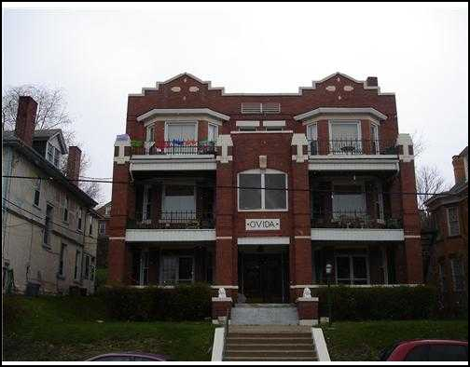
MLS#: 911159 Status: Active
Multi-Unit 37N Bryant

Area: Bellevue List Price: $395,000
County: North Allegheny
Address: 37N Bryant Zip Code : 15202
Dir: LIncoln Avenue to N. Bryant

Lot: 500x21 Acres:
Map#/Block#/Lot#/Info: 0160-S-00008-0000-00

Zoning: School Dist:
School Trans: Public Trans:
General Information

GAI: $63,400  Vacancy: 0 % | Maintenance: Other Exp: | $2,000 | Total Units: | 9 | Beds | Baths Full | Partial | Rent
GOI: | NOI: | $40,660 | 1 | 6 | 1 | 1 |  | 450-575
Insurance: $1,200 | Cash Required: |  | 2 | 3 | 2 | 1 |  | 700-750
Utility Exp: $7,300 |  |  | 3
 |  |  | 4
Remarks
Beautiful Exterior, Solid Brick Building in Strong Rental Market...9 Units- Fully Occupied..Units have large patios.. .

Agent Remarks
Listed right around a 10% CAP RATE.. Motivated Seller..This property has been undermanaged for years. Rents could be much higher. All 1 BR's can be around 575-600. And all 2 BR's can be around 800. Easy opportunity to raise rents and increase value instantly..

Features
Type Property: Other Years Old:
Basement: Construction:
Parking: Insulation:
Show: Appointment With Listor Roof: Utilities Avail:

Office Information

Value: Market Value - $135,500

Tenant Occ: Y
Taxes: $5,350

ICD: N Entered: kg:OFC Foreclosure:

BAC: 3%
SAC: na

TLC: na Short Sale:

Owner: Layton Properties Tour Date:
Contact: Listing Agent Phone: 724-699-4707
Agent: Keane George Phone: 724-699-4707 Cell Phone: 724-699-4707
List Office: WIN REALTY ADVISORS, LLC Phone: 412-415-3328 Office ID: 84001

Tour URL:

List Date: | 04/11/12 | Expire Date: | 04/11/13 | Pending Date:
Sold Date: |  | Sold Price: |  | Sold Terms:
Selling Office ID: |  | Office Name: |  | Phone:
Selling Agent ID: |  | Agent Name: |  | Phone:
DOM: |  | Buyer Name: |  | Seller Concessions:

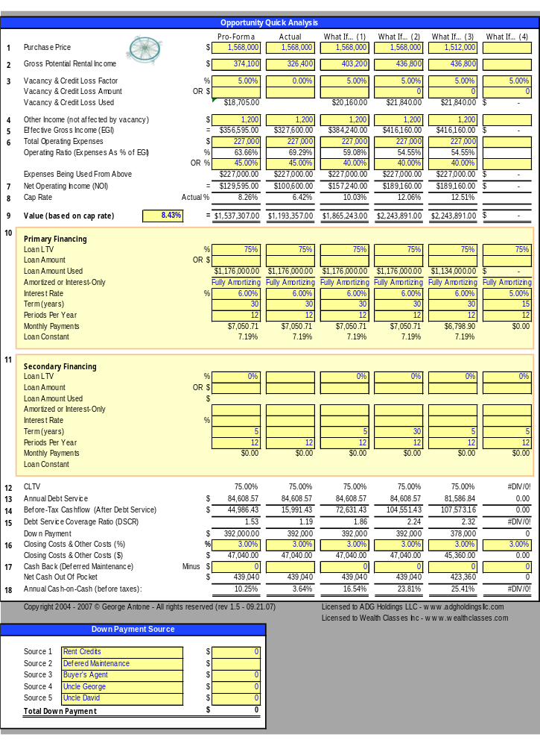
- Insert here one of the following appropriate links so they can download the book(s) that are appropriate for what they want to invest in 1st:

  - Flipping For Profits Without The Risk
    - Link: https://www.myinvestmentservices.com/free-ebook-flipping/
  - Rental Profits Without The pain
    - Link: https://www.myinvestmentservices.com/free-ebook-rental-profits/
  - Wholesaling So Everybody Win
    - Link: https://www.myinvestmentservices.com/free-ebook-wholesaling

Please read what others have to say:
“Gary,
I am humbled. I can not put into words the contributions you have made to my life. This testimonial is the smallest possible demonstrable token of my love and appreciation for you!!!
For over 4 years, Gary Wilson has been crucial to the continuing success of Inventure Investments. Gary's unrivaled integrity, guidance, and experience matches perfectly our organizational Values and Goals. Personally and professionally, I have come to depend on Gary Wilson as a vital asset in the accumulation of real estate assets. Today, opportunities are everywhere. Gary Wilson is a dynamic 'Force Multiplier' in the domain of Real Estate and Real Estate Investing. Thank You, Gary!

Victor T. Sears
Victor T. Sears, CPS
President,
Inventure Investments LLC “

“Dear Gary,

As an airline pilot I would never think of going to work without thorough preparation and knowledge for the course and equipment to be flown. Preparation is the key to success. As a real estate investor, such preparation is also the key. I have had many dealings, conversations, and advice planning with you. When experience, knowledge, and integrity matter, there is only one call I make. That call is number one on my speed dial. It is without question, Mr. Gary Wilson.
Sincerely,
Peter C. Lewis”

“I started working with Gary about 5 years ago when I decided to get
serious about real estate investing. Since then I had purchased 7
homes in a 3 year span before I was unable to keep going due to
internal problems. Even after I stopped looking for houses, Gary would
still take time to answer my calls and questions.
In working with him I found a mentor that was willing to take the
time to explain how to set up various parts of my business along with
a Realtor that I could trust. Gary would tell me if a potential deal
did not look good and why. My business partner and I referred to him
as a "Boy Scout", because to find someone whom you can trust to do the
right thing in this field is rare. Thanks for all your help Gary!
Richard Baronti “

Win Realty Advisors
Helping the World Build Wealth and Income through Real Estate

Pittsburgh has been and remains a safe haven for Real Estate investors and homeowners alike and continues to be ranked #1 in too many articles to list here. You’ve seen them. You’ve heard Warren Buffet state that if could buy 1,000 single family homes he would. Experts agree that we have at least 12 years of opportunity to increase income and value in Rental Real Estate. You have a recognized authority right here in Pittsburgh who, through Win Realty Advisors, Win Rental Management and Win Settlement Services, provides the solid platform for you to use and invest successfully in Real Estate.
If you are like most other doctors, and some of our other clients, and are fed up with the stock market and financial advisors telling you to just be patient and you previously considered investing in Real Estate too time consuming then please call or email me and the Win Realty Advisors Team to find out how you can finally begin putting your hard earned money to good use. We not only invest in Real Estate, we invest in people just like you. It’s easier than you may have thought. We look forward to helping you. Please take the 1st step and call today. There are no obligations. Sincerely, Gary Wilson.
412-415-3328
Gary@WinRealtyAdvisors.com
www.RealEstateandPittsburgh.com
Gary Wilson, Broker/Owner
Helping the World Build Wealth and Income through Real Estate

